Basic Health Check Doc

- First of all check the System Connectivity via putty, if it’s not accessible then go to console (vcenter) and try to login from there. You can also try to ping the server to check the reachability.
- Always check messages file for fault & errors.

How to check CPU Utilization:

- Run the “top” command to check overall system performance.

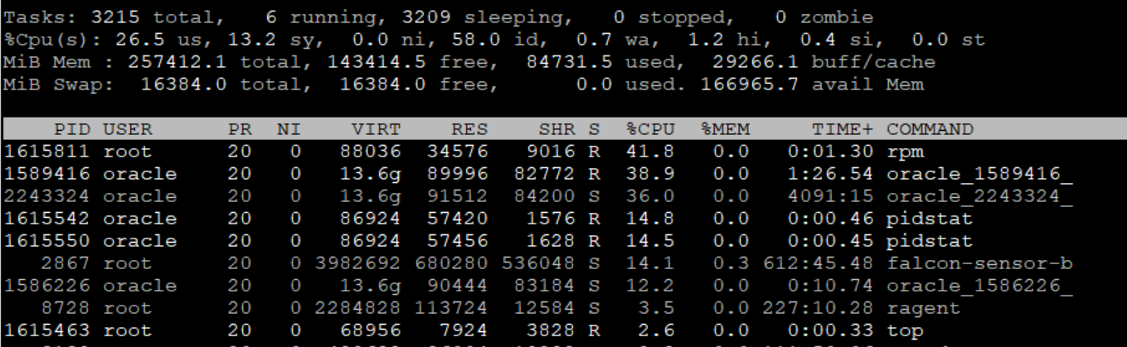

- If you want to check the utilization of individual CPU core then run top and press 1.

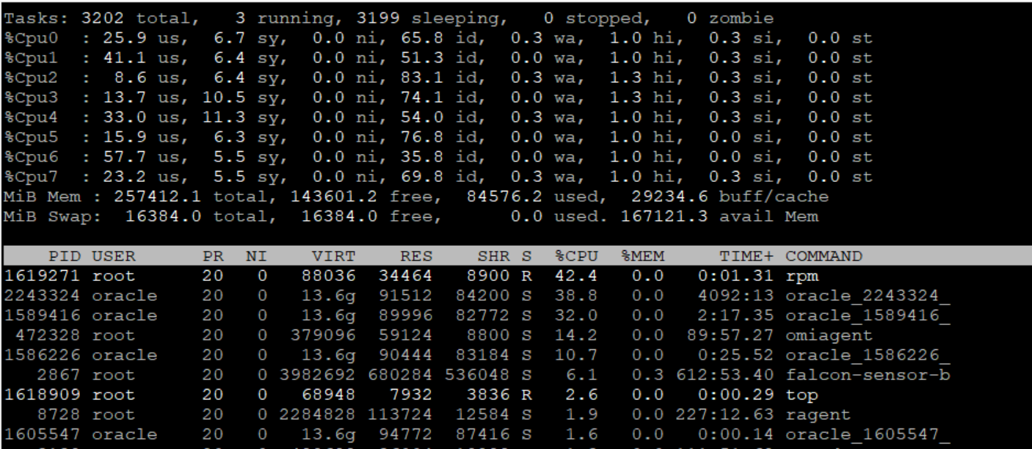

- If you want to add any other column in top output, like PPID, last use CPU etc. then run “top” command press “f” and select the desired option by pressing “space bar” and hit esc button to return to the top output with desired column.
Here I am selecting last used CPU-core by the process.

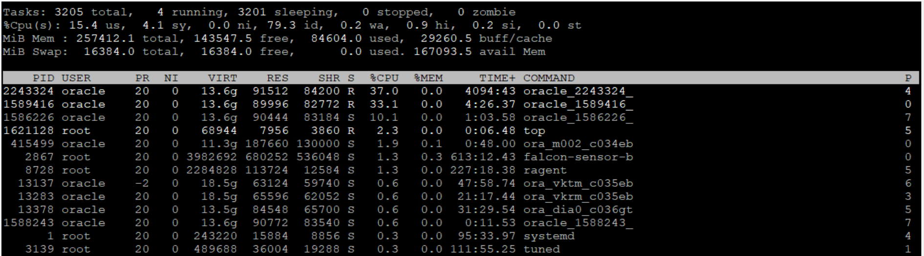

- To check the threads of individual process via “top” command :

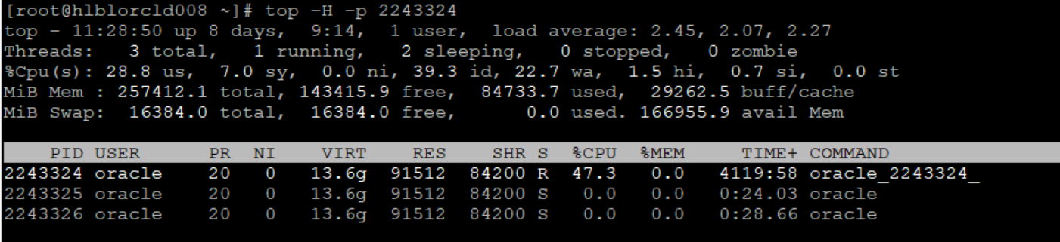

- To check CPU core on the system:
# lscpu | grep CPU” or “nproc”

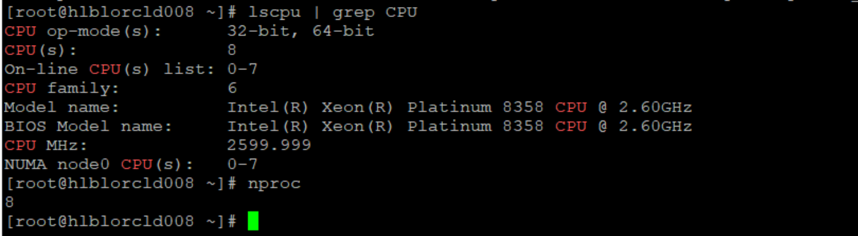

- To check the CPU affinity of individual process:
#taskset -c -p 1678552

- You can run “sar -u” to check the CPU utilization of entire day starting from 00:00 hrs:

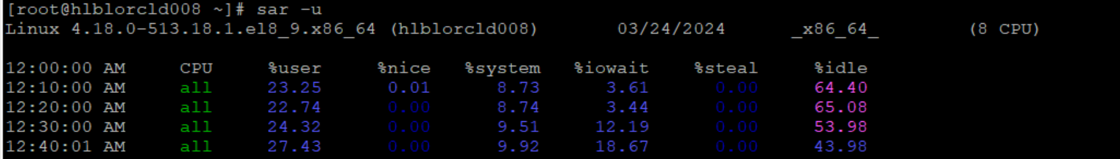

%iowait - Show the percentage of time that the CPU or CPUs were idle during which the system had an outstanding disk I/O request.

To check the historical CPU utilization of specific date (maximum of one month):

# sar -u -f /var/log/sa/sa20 (to check the data for date 20th)

To check Load average and run queue

# sar -q

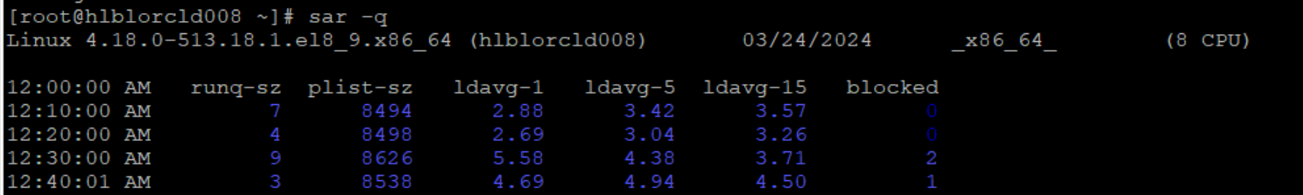

Similarly, you can check the historical run queue with below option:

# sar -q /var/log/sa/sa20 (to check the run queue historically for date 20th)

Note – “In ideal scenario load average should not exceed the number of cores” If it is going high then CPU is being over utilized.

- To check the top 10 cpu consuming oracle process:

# ps -o pid,user,%cpu,start,time,command ax | sort -b -k3 -r |egrep 'PID|ora.*(LOCAL=NO)' | head -10

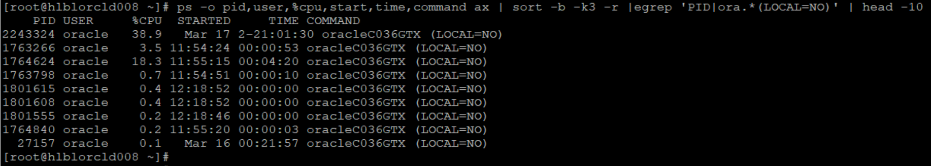

How to check RAM Utilization:

- To check available memory RAM on the system:
# free -h

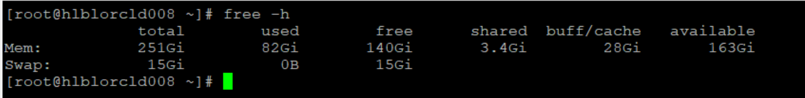

Note – If you see little difference in total memory and allocated memory in “free” command output then the difference is used by the kernel for memory table.

- You can run “sar -r” to check the memory utilization of entire day starting from 00:00 hrs:

Available Memory = (kbmemfree + kbbuffers + kbcached)
Always recommended to use “top” or “free” command.

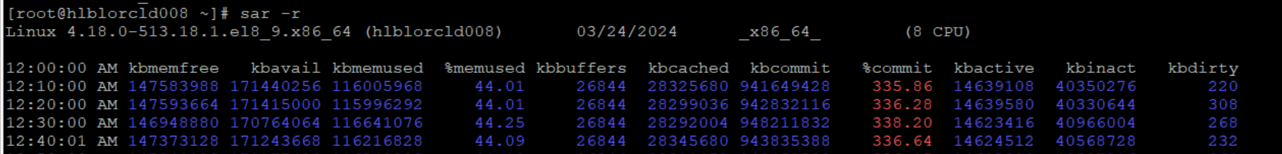

This output is little confusing as sometimes it shows “%commit” memory more than 100%. Because kernel overcommit the memory to the process from the actual available memory. Which you can control to some extent by changing the below kernel parameter:

# sysctl vm.overcommit_memory

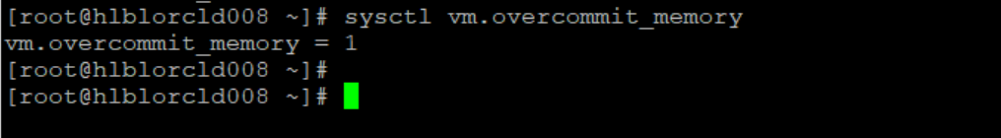

0 – Overcommit but refuse any unreasonable memory request on the heuristics base. This is the default mode. overloading memory is possible with this setting.

1 – Always overcommit. (Recommended) the kernel performs no memory overcommit handling. This increases the possibility of memory overload but improves performance for memory-intensive tasks.

2 – Never overcommit. (it is recommended only for systems with swap areas larger than their physical memory.
- You can check the memory utilization using the “top” command:

# top -o %MEM (to check the topmost process utilizing memory)

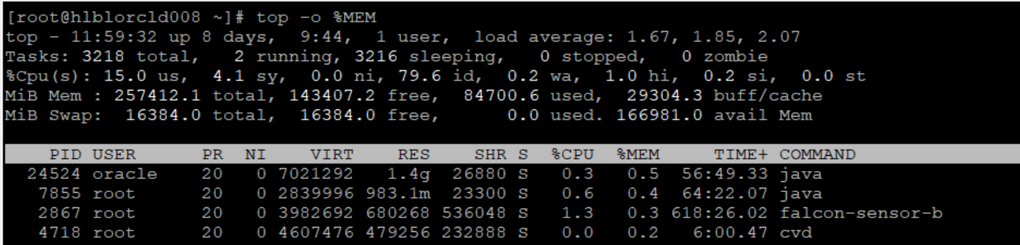

- To check the memory utilization of an individual process using “top”:

# top -p 24524

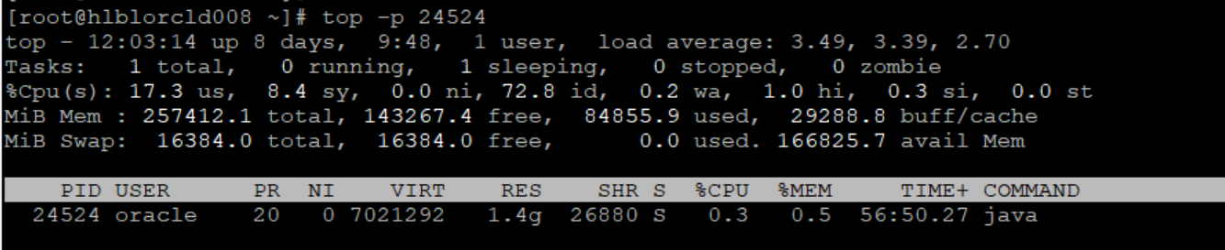

- To check the top 10 memory consuming oracle process:

# ps -o pid,user,%mem,size,command ax | sort -b -k3 -r |egrep 'PID|ora.*(LOCAL=NO)' | head -10
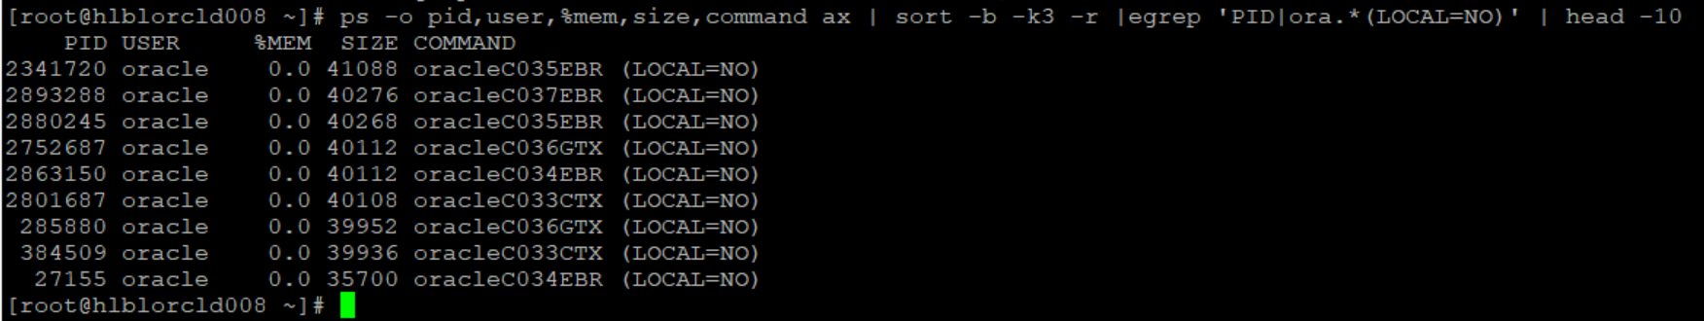
Now if you want to check individual memory map of the process:
# pmap -x 2341720 | egrep -i "address|total"

Note – RSS is resident memory size (physical memory) used by the process. Here in above command it is 138 MB.

- To check java heapsize & its statistics:

# jstat -gc 1832 (if “jstat” is installed)

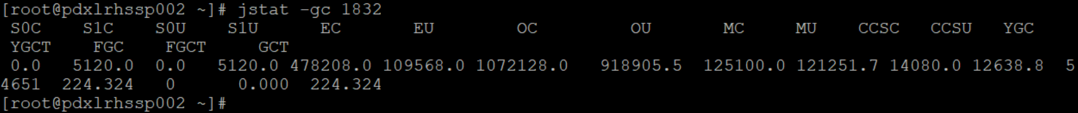

# jstat -gcutil 1832 (if “jstat” is installed)

# ps -ef | grep -i 2941 (In below output java heap min & max is set to 65GB)

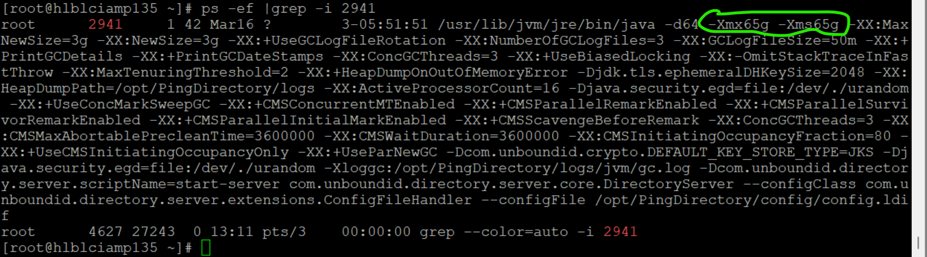

Note – Command to check the associated rpm of any binary/command.

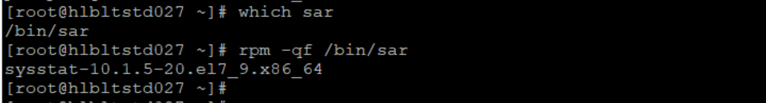

Disk Utilization:

- Command to check filesystem utilization:

# df -h

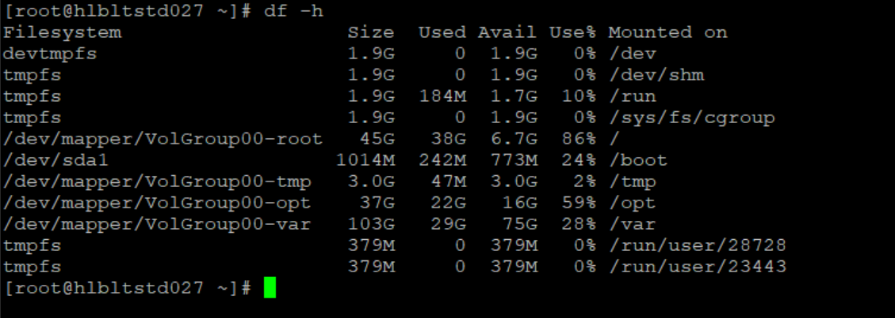

- Command to check the hidden space used by deleted files:

Linux:

# lsof | grep -i "deleted"

Solaris:

# find /proc/*/fd -type f -links 0 -exec ls -lrt {} \;

- Command to check disk and logical volume I/O statistics:

# iostat -N

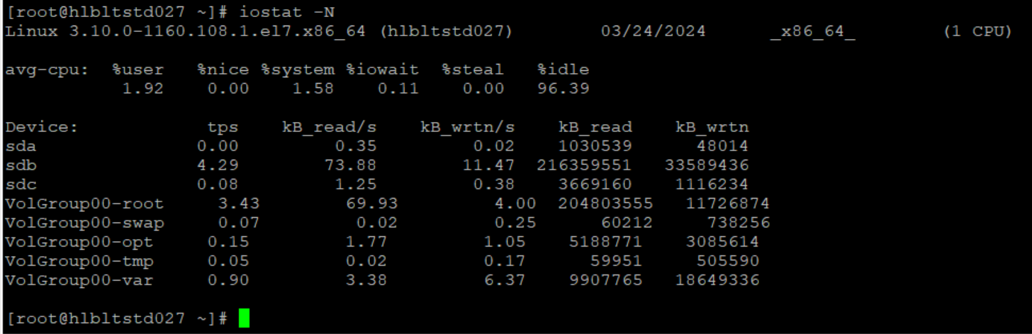

- To check I/O statistics only for a particular device.

# iostat -p sda

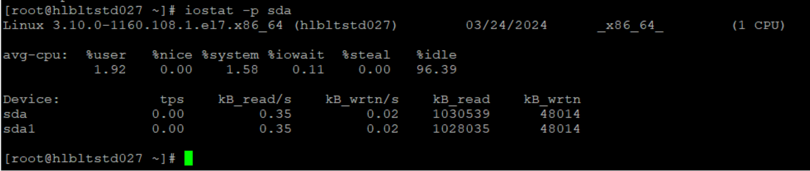

- To check extended disk I/O statistics:

# isotat -x

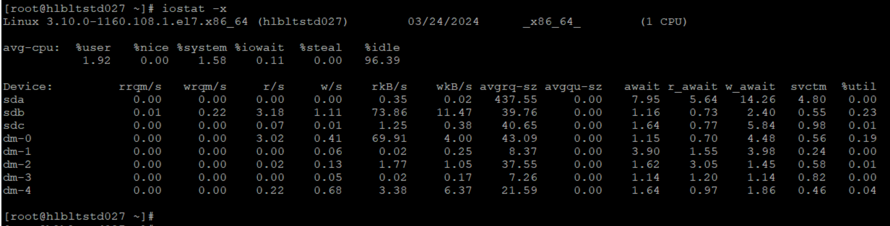

- To check extended disk I/O statistics of particular disk:

# iostat -x sda

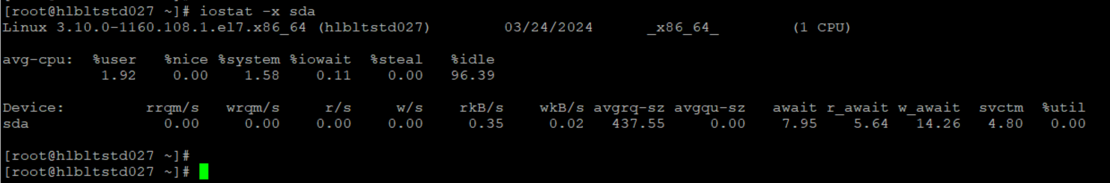

- To check disk I/O statistics every 2 seconds of 5 time:

# iostat -N 2 5

Port Status:

- To check port binding with application/service.

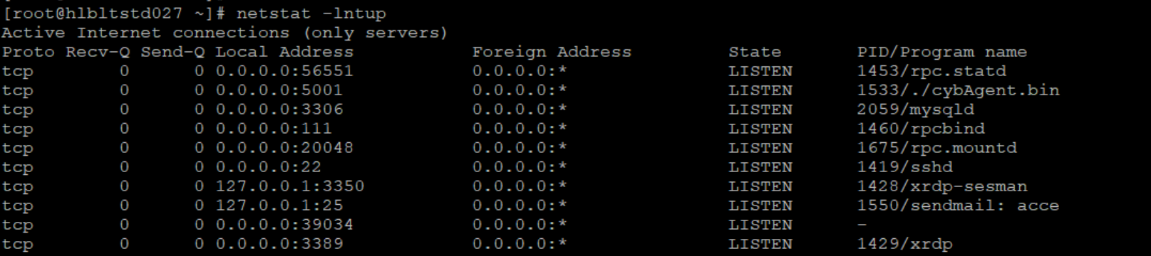

Note – If the port is not showing in above output then the service/application is not running. Port should be bind with application/service to listen.

For example, the below ESP Agent is bind with port 5001.

- You can also check port connectivity by using below command.

# telnet seq1 5001

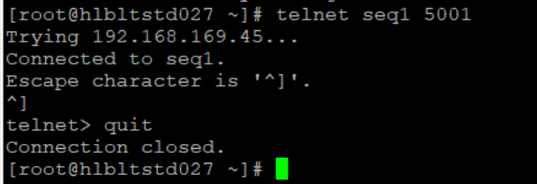

# nc -zv seq1 5001

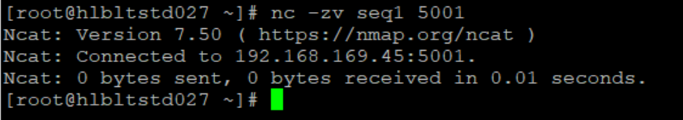

Network Connectivity:

- You can check the connectivity of Host via ping and ssh.

- To check the connectivity between two hosts:

# traceroute seq1

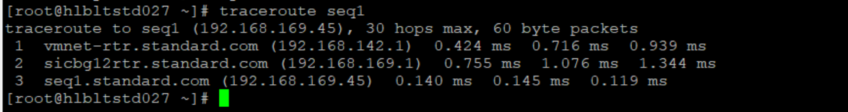

To check the port connectivity between two hosts, you can use the same “telnet” and “nc” command.

- To capture the dump on interface:

# tcpdump -w /tmp/tcpdump.pcap -i ens32

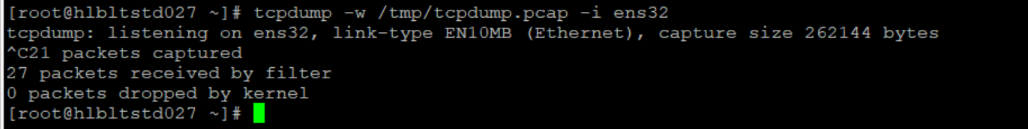

- To read the dump file.

# tcpdump -r /tmp/tcpdump.pcap

- To capture specific number of packets:

# tcpdump -c 5 -w /tmp/tcpdump.pcap -i ens32

- To capture the packets in ASCII mode:

# tcpdump -A -w /tmp/tcpdump.pcap -i ens32

- To capture the packet for a specific host.

# tcpdump -w /tmp/tcpdump5.pcap -ni ens32 host pdxlrhssp002

- To capture the packet for a specific source.

# tcpdump -w /tmp/tcpdump5.pcap -ni ens32 src host pdxlrhssp002

- To capture the packet for a specific destination.

# tcpdump -w /tmp/tcpdump5.pcap -ni ens32 dst host pdxlrhssp002

- To capture the packet for specific port.

# tcpdump -w /tmp/tcpdump5.pcap -ni ens32 port 443

- To capture http traffic from either host.

# tcpdump -ni ens32 host 192.168.1.11 or host 192.168.1.15 and tcp port 80

- To capture tcp traffic from.

# tcpdump -w /tmp/tcpdump5.pcap -ni ens32 port 443 tcp

- To capture traffic from specific network.

# tcpdump -w /tmp/tcpdump5.pcap -ni ens32 src net 192.168.0.0/24

